Publisher: | Moody Publishers
Date of Publication: | 5/12/2021
Number of pages: | 240
Book Club rating: | 4.5
Reviewed by: | Megan Cremer

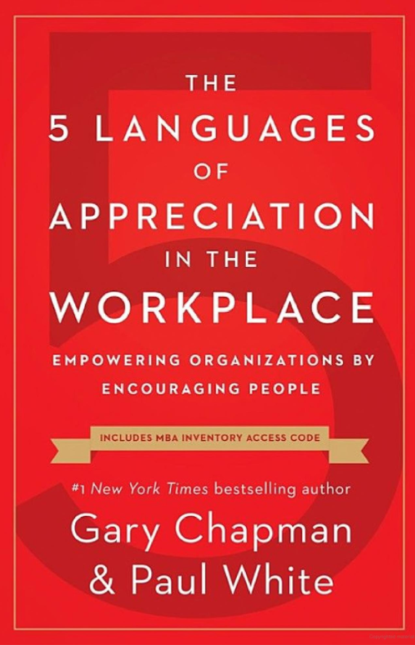
Plot Summary: Gary Chapman and Paul White take the concept of The 5 Love Languages and apply those ideals to the workplace. They have found that there is a direct correlation between an employee’s career satisfaction and their engagement with how appreciated they feel. Throughout the book, they provide case studies and resources that back up this theory that when employees are more engaged and motivated because they feel genuinely appreciated, that also translates to greater revenue, attendance, morale, and greater productivity.
But how do you go about showing appreciation and not just recognition, as those are two very different things? And how do you know what will resonate, as every person has different needs? The authors take the same concepts of the Love Languages and apply those to the workplace: Words of Affirmation, Quality Time, Acts of Service, Tangible Gifts, and Physical Touch. With each section they advise on how to express appreciation so that it is received appropriately.
If you would like to know what your Language of Appreciation is, they have created the Motivation by Appreciation (MBA) Inventory where you can answer 40 questions and get your results.

Book Club Meeting Discussion:
What did we learn?
- It was a good reminder to ask people what they need and be receptive rather than assume
- Agreed with the book that appreciation is a motivator; Shared examples of a supportive manager that provides feedback often and an organization that sends gifts randomly to acknowledge employees and show appreciation
- The book discusses how managers usually carry the weight of having to appreciate their teams, but peer-to-peer is also important. Colleen shared her experience of sharing her appreciation with her manager. It is also important to share appreciation across all levels.
- We discussed if our companies show appreciation and how. Some organizations do not put the same emphasis on showing appreciation to employees who are contractors, while others make it a way of their culture and are often creating a forum to call out employees for their exceptional work.
- Physical Touch: Can be controversial and not well received; post pandemic we will need to be more conscious and gauge appropriateness
- Recognition vs Appreciation
  - Recognition is more general – not as well received
  - Appreciation is more specific and personal, genuine
- What do you do when you don't actually appreciate someone?

Personal Comments:
I really enjoy this book and the ideals of it. This personally resonated with me and my experiences with my current and past organization. I feel I am currently thriving professionally because of the company I work for and the culture they promote. They put their employees before customers and shareholders and they genuinely care and appreciate every single employee- which is impressive when the enterprise consists of over 7k employees. They still manage to make me feel appreciated and I am nowhere near the top of the org chart. In addition to that, I have an amazing manager who is supportive, and I always feel appreciated and like I make a difference. As the book mentioned it is not about money, appreciation really does make or break a job, in my opinion.
I will certainly be able to apply what I learned from this book in my day to day life at work and home. In the past when I have lead project teams, I would recognize the team for their joint accomplishments but then in 1:1s I would also praise the team members personally for their direct contributions, but perhaps it was not received as well as intended, so this book will aid in recognizing each individuals language of appreciation so that the message is well received.

