Publisher: | Knopf
Date of Publication: | March 12, 2013
Number of pages: | 240
Book Club rating: | 3.83 out of 5
Reviewed by: | Colleen Zettler
Plot Summary:
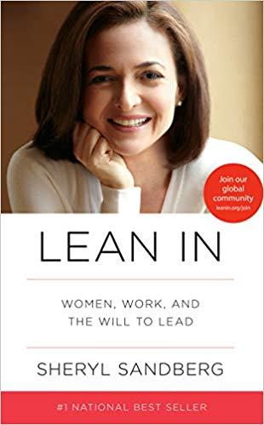
In Lean In, Sheryl Sandberg reignited the conversation around women in the workplace.
Sandberg is chief operating officer of Facebook and coauthor of Option B with Adam Grant. In 2010, she gave an electrifying TED talk in which she described how women unintentionally hold themselves back in their careers. Her talk, which has been viewed more than six million times, encouraged women to “sit at the table,” seek challenges, take risks, and pursue their goals with gusto.
Lean In continues that conversation, combining personal anecdotes, hard data, and compelling research to change the conversation from what women can’t do to what they can. Sandberg provides practical advice on negotiation techniques, mentorship, and building a satisfying career. She describes specific steps women can take to combine professional achievement with personal fulfillment, and demonstrates how men can benefit by supporting women both in the workplace and at home.
Written with humor and wisdom, Lean In is a revelatory, inspiring call to action and a blueprint for individual growth that will empower women around the world to achieve their full potential.

Book Club Meeting Discussion:
This book kicked off the inaugural meeting of the PMINEO Women in Project Management Book Club.
6 women came together to discuss Sandberg’s bestselling book and everybody found the book informative and useful in defining unconscious patterns that could be barriers to moving ahead in the corporate world. Every single undoing of a woman’s career is examined thoughtfully in the book and Sandberg provides recommended remedies. The discussion focused on framing office culture and implicit biases each of us had experienced and sharing our individual stories which facilitated a lively discussion that was enlightening and through provoking.
Personal Comments:
I’d been meaning to read this book since it came out and never found the time. I was thrilled to have the ‘excuse’ to read it and wasn’t disappointed. There’s a reason it’s a best seller. I found the book helpful in working through office culture issues I didn’t even realize I was having.

