Publisher: | Penguin Group (USA) LLC
Date of Publication: | 2014
Number of pages: | 252
Book Club rating: | 4.5
Reviewed by: | SHASHA ZHAO
Plot Summary: (approximately 350-500 words)
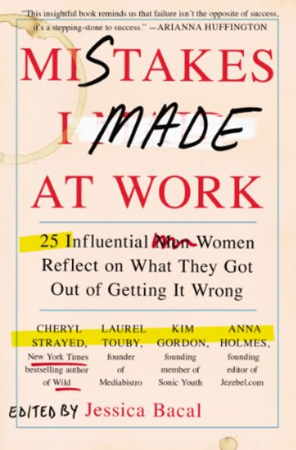
Mistakes I made at work-25 influential women reflect on what they got out of getting it wrong is the book help women at any stage of their life and at any work occupation to realize that no one is perfect- including the most outstanding accomplished women. This book makes the point and reminds us that failure isn’t the opposite of success, but instead a necessary stepping-stone to lead to success. All the stories are conducted by interview by author Jessica Bacal with total twenty-five accomplished women and divided into five major sections, including Learning to take charge of your own narrative, learning to ask, learning to say no and Learning resilience.
The major learning points including:
- Be aware that as women, we always feel “pressure to be perfect, accomplished, thin and accommodating”. Therefore, it takes extra efforts to allow us make mistake to become success, instead of letting this stereotype social expectation hold us back.
- It is very important to be able to reflect on our own stories, to understand who we were before, who we are now, who we will be and where we are going. This helps us to make decisions small and big, short term and long term, and make sure we always become better of ourselves eventually.
- No matter where you go and what job you take, no matter you like or not, you need to make sure to work on boosting your own career skills, building skills and capacities to take with you to next level job.
- Don’t be afraid to quit. Find out what you really want, it is ok to quit once you find out the path you thought was right turn out not. We are the one living our own life. Other’s opinion and expectation are important, especially parents. But the goal is one, only one – they want us happy. So be brave, take the leap and move on.
- Do not be afraid to ask, help, opinions from others. Asking others is actually the great opportunity to collaborate and boost the relationship and innovation. For most complex and difficult situation, there is no way you could take those battles by yourself and there is a lot of ways to fail. Be ready to ask help.
- Dr Martin Luther King Jr: Don’t just ask what the world needs. Ask what makes you come alive and go do it. Because what the world needs is people who have come alive.
- How to act when you see someone else make an error- be the compassionate listener. Help the person acknowledge the error without shaming him or her. it is important to help that person make distinction- it is not you were wrong; it is your decision was wrong. The error is in your action, not in yourself.
- Even when you are grateful to have that first job, it is still a good idea to negotiate. During the salary negotiation, never talk about what you “need”, and never be apologetic.
- Don’t let self-imposed constrains or the idea that there is certain kind of work you are “supposed to do”. Get in the way of taking risks and pursuing what you love.
- Only you can determine your future, only you can decide who you will be.

Book Club Meeting Discussion:
- Everybody believe this is great book and relative to their personal lives. Some even wish they could read this book by their early twenties. Some already recommend this book to friends and kids.
- We discussed about the mistakes we made before or currently about negotiation salary. How the story in the book shed the light about the right mindset and strategy to lead a successful salary negotiation.
- We discussed about our reaction about criticism. Some shared their own experience about overact to other’s criticism or negative feedback.
- We also discussed the work-life balance. There is really no clear boundary between work and life. What we need to learn is to how to blend both together.
- Everybody agreed that it is important to work on improving yourself and learning new stuff. Life will be more enjoyable.
- Fail hard, fail fast and fail often.

Personal Comments: (approximately 200 words)
I enjoy reading this book so much, it turns out a big pleasant surprise, not only fun to read to the story, the concept conveyed is strong and totally changed my mind. I will take suggestions from this book and apply to my life.
The highlights for me are:
- It is ok to make mistakes, no one is perfect. For myself, I always try to be perfect, which hold me back without noticing. I would be thinking too much and try to sound smart in the classroom or in the meeting. But I lost the opportunity to focus on others.
- It is ok to quit. I don’t like to be a quitter and always proud to be persist. But after reading the book, my mind changed. I realize that in some situation, the reason I still keep going, not because it is still the right path for me, but because I don’t want to be a quitter and disappointed people have faith on me.
- Do not be panic if you do not like your job and you could not move forward yet. I used this suggestion right away. Because the economy, our business not as good as before. After couple of big laid-off, like everybody, I took multiple different tasks which I am not interested. Instead of depressing, I use this as opportunity to build my skill kits and my capacity, which keep me engaged into work and gain skills. At some time, learned to build connection with all the tasks, because then you do not connect with the work you are doing, it can feel nearly impossible to get it done.
- How to act when you see someone else make an error- be the compassionate listener. Help the person acknowledge the error without shaming him or her. Before reading the book, I would point out other’s mistake or error right away. But now I would talk to the person in a private area to discuss, also make sure the person know it is wrong method, nothing is wrong with the person.
- Even when you are grateful to have that first job, it is still a good idea to negotiate. During the salary negotiation, never talk about what you “need”, and never be apologetic. – this is the best suggestion for me, since I never negotiated in my past few jobs. I felt into the trap that I am grateful for the job and I don’t want to be greedy. But I should take the negotiation as business, to get fair deal for myself.
- Don’t let other people define who you are. This is very important to keep in mind. Most of time, I care so much about how others think about me and let others define who I am unconsciously. In work, when I am not appreciated by others, specially by boss at work, I sometimes start to doubt my own ability. Even I have my friends from work keep tell me I am very intelligent. I take the suggestion; I should not see the negative sign as a my worthlessness.

