Publisher: | Jossey-Bass; 1 edition
Date of Publication: | April 10, 2012
Number of pages: | 224
Book Club rating: | 3.8
Reviewed by: | Megan O’Malley

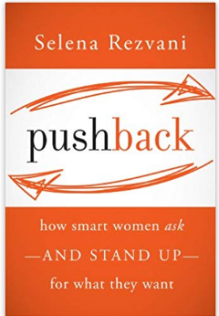
Plot Summary:
The objective of this book is to help the reader learn how to advocate you. Selena Rezvani outlines reasons why women don’t advocate themselves or negotiate for better terms. Rezvani helps understand how to leverage your skills, negotiating in general; confronting issues without damaging relationships; having a critical discussion when there are disagreements; negotiating your career. Rezvani outlines the reason why to push back. She helps you understand your pushback style and how to approach negotiations or difficult discussions. Rezvani provides an outline on pulling together your data, discussion points, and how to mentally prepare for the discussion. Once you’re armed with your discussion points, she outlines how to maneuver the issues during the discussion and then discusses the post negotiation steps of documenting the decisions and discussion in order to hold everyone accountable. The book ends with a chapter detailing how you are the only one that will advocate you and how to continue to use your pushback skills.
The book has real life examples of women who have pushed back in their career. The illustrations of how pushback helped others and the outlines of how you can do it too, make pushing back a reality.
Pushback is a simplified and approachable illustration on how you can leverage your skills and promote yourself

Book Club Meeting Discussion:
Discussion topics from the roundtable:
- Observations on how children are brought up: Girls look for approval, Boys just do.
- Old school norms were brought up and how women should do themselves a favor and push back from those “norms”.
- How this book has helped us or will help us in future discussions.
- Situations we wished we pushed back more.
- How silence can help negotiations or critical discussions.

Personal Comments: (approximately 200 words)
What I liked about this book: Selena Rezvani made the process of pushing back easy to follow in 7 chapters. Selena outlines the process from why you should push back in chapter 1. By the end of reading all the reasons, the better question would be why you shouldn’t push back. There’s financial reasons tied to negotiating your personal standing with your career, why you should do your homework to get the best benefit. Chapters 2, 3, 4, talk about preparing yourself. Chapter 4 hit home for me. When I was new at managing big projects that had tight deadlines, I would prepare by going through what discussions with cross functions would go and what I needed to get from them. I would do all the homework, understand what I needed, then prepare mentally. I wasn’t just managing a project. I was negotiating with the team to produce deliverables for the customer and get things done. Chapter 5 helps keep your negotiation on track with clarifying questions to ask if you receive push back. Chapter 6 focuses on the importance of documenting the decisions made and follow up. Chapter 7 describes why you own your career and how to keep building on your skillset. This would be an excellent book to re-read if you have an upcoming negotiation.

