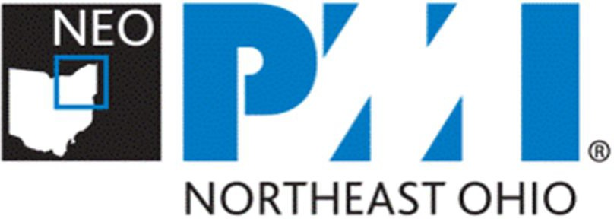

Introduction

Position your brand with the recognized leader in project management. Through print, online, social media, event and direct mail channels, PMINEO provides an array of opportunities from which your brand can reach the desks of key decision makers, people with purchasing responsibilities and affluent consumers.
PMINEO Sponsors and Digital Advertisers reach a captive audience of project management practitioners through social media, our premier PMINEO newsletter publication, our website, e-mail marketing and other opportunities.
By becoming a Sponsor, your generous support plays a critical role in helping us to continue funding our popular professional development programs, monthly lecture meetings and events, PMI Breakfast Forums, educational programs for students at the leading colleges and universities in Northeast Ohio, and more.
Through your financial and other contributions, PMINEO keeps membership fees low, making PMINEO membership an incredible value.
With this array of sponsorship opportunities described in this packet, PMINEO invites that participation of organizations that are serious about the continuing advancement of the premiere professional project management ecosystem in Northeast Ohio.

WE THANK ALL OUR SPONSORS AND STRATEGIC PARTNERS FOR THEIR SUPPORT!

About Us
Worldwide membership in PMI® is more than 450,000 professionals! PMI has over 280 geographic chapters in more than 185 countries. As one of these charted PMI chapters, we serve as the premier professional association for Project Managers and for the project management profession in Northeast Ohio (PMINEO).
Our Chapter, PMINEO reaches approximately 1,600 professionals in project, program and portfolio management located in Northeast Ohio.
Northeast Ohio PMI professionals come from virtually every major industry.
- aerospace,
- automotive,
- business management,
- construction and engineering,
- financial services,
- information technology,
- pharmaceuticals,
- healthcare, and
- Telecommunications.
Our chapter serves an area extending from Cleveland and its surrounding suburbs, East to the Pennsylvania border, West to Sandusky, and South through Akron, Canton, and their surrounding suburbs. With approximately 4 million people, a labor force of over
2 million and a regional gross domestic product of nearly $170 billion, PMINEO’s region ranks as the 15th largest CSA in the United States.

Event Sponsorship Opportunities

Solidify your position as a leader in the project management profession. Become a sponsor at any of our upcoming events. Here is just a partial list of the high impact events conducted by our Chapter.

Annual Kerzner Awards Dinner.

  - Recognition of Personal Professional Excellence: Annual Kerzner Award bestowed on an individual project management practitioner who best demonstrates project management excellence.

  - Industry Recognition of Organizational Excellence in Project Management. Annual Kerzner Award which recognizes the large and complex project that best delivers superior performance of project management practices and superior organizational results.

- Professional Development Day Seminar: Signature event bringing to Northeast Ohio a forum where professionals can network and exchange ideas with the top professionals in the project management field. Notification of other Professional Development opportunities held in the local geographic area.

- International Project Management Day Seminar. PMINEO typically co-conducts International Project Management Day with Baldwin Wallace University. This celebration of all things project management typically includes a series of seminars and events located on the Baldwin Wallace campus.

- Chapter Meetings. Meetings are scheduled January through November. A professional presentation is conducted by an external speaker selected because of their proven expertise and experience in a related topic. See the complete list of currently available PMINEO programming and events on our website at https://pmineo.org/events/event-registration

- PMO Forums. Breakfast meetings that focus on issues and opportunities unique to project management offices located within the region. Topics include those that are of interest to enterprise program and portfolio management.

- Executive Forums. Breakfast meetings that focus on issues and opportunities that face executives and where effective project, program and portfolio management may solve those opportunities.

- Social Networking Events. Quarterly events allowing Members to network in an unstructured environment.

- Outings. Seasonal events typically conducted by PMINEO chapter at various times throughout the year. Outings are held at interesting and appropriate locations in keeping with the seasons. Outings promote fellowship and network among Members.

Event Sponsorship:

Benefits | Single  Event | Gold | Diamond | Platinum
Number of events sponsored | 1 | 1 | 2 | 2
Logo inclusion in banner on homepage | 1 Quarter (of event sponsor) | 12 months | 12 months | 12 months
Event Admissions | 2 admissions for single event | 4 per 12-month period | 6 per 12-month period | 8 per 12-month period
Logo included on event page | Yes | Yes | Yes | Yes
Elevator pitch on event details pages | Yes | Yes | Yes | Yes
Article posted in Chapter NEWS promoting sponsorship of event | Yes | Yes | Yes | Yes
Article promotion in newsletter | Yes | Yes | Yes | Yes
Right margin ad in monthly newsletter | 3 months | 6 months | 9 months | 12 months
Event promotion on Chapter social media | Yes | Yes | Yes | Yes
Sponsor logo included in Chapter slides | Yes | Yes | Yes | Yes
Introduction of sponsor personnel in attendance at event | Yes | Yes | Yes | Yes
Opportunity to host networking session prior to event | Yes | Yes | Yes | Yes
Investment Required | $500 | $1,750 | $2,500 | $3,195
Estimated Value of Benefits | $2,200 | $ 3,010 | $ 5,900 | $ 8,400

Additional opportunities included, sponsoring a network event, special PMI dinners and other types of event. Contact us for specific details and pricing.

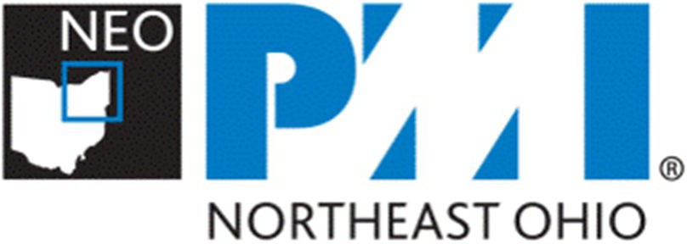

Closing / Contact

Thank you for considering an investment with the Northeast Ohio Chapter of Project Management Institute (PMINEO). We have been promoting the Project Management profession in Northeast Ohio since 1996 and this has resulted PMINEO growing into one of the largest PMI chapters. Since our founding in 1996, our chapter has become the most vibrant project management ecosystem in Northeast Ohio. By joining with us as a Sponsor, you are choosing to become an integral contributor, ensuring that our programs and services continue to evolve so that we can enhance the delivery of value to our members and sponsors.
PMINEO is making project management essential for business results in Northeast Ohio®

Contacts

For additional information regarding PMINEO’s Sponsorship opportunities and / or any of the programs offered by PMINEO, please contact:

For Event Sponsorships
Ed Ruper, PMI-PBA | execprograms@pmineo.org | 330-328-6275
Joseph Anastasi CAPM, PMP, PMI-ACP | outreach@pmineo.org | 216-548-7462

THANK YOU AGAIN FOR YOUR SUPPORT!

PMINEO SPONSORSHIP INFORMATION AND CONTRACT FORM
Instructions: Save this form to your computer and complete all sections electronically. Upon receipt of payment, the Northeast Ohio Chapter of Project Management Institute (PMINEO) will e-mail you confirmation for your files.

NAME OF COMPANY / ORGANIZATION
NAME OF CONTACT PERSON | TITLE OF CONTACT PERSON
ADDRESS
CITY | STATE | ZIP | PHONE
EMAIL | WEB ADDRESS

CHAPTER SPONSORSHIP LEVEL
Please indicate your sponsorship commitment (x). For Digital Sponsorships please indicate whether you are paying monthly (x) or are opting for the annual pay option (x) to receive the discount shown.
 | Single Event | $795
 | Gold | $1,750
 | Diamond | $2,500
 | Platinum | $3,195

EVENT SPONSORSHIP

Sponsorship Fee Amount ($) | Total Amount Enclosed

PAYMENT OPTIONS
Please charge our credit card. VISA MasterCard Discover
have enclosed check (payable to Project Management Institute Northeast Ohio Chapter). We are submitting a purchase order and will pay the invoice within 30 days of its receipt.
In-kind sponsorship.
AUTHORIZED SIGNATURE
SEC CODE
EXP DATE
CARD NUMBER
NAME ON CARD
SIGNATURE Acceptance of this application by PMINEO constitutes a contract.
NOTE: Returning this document to PMINEO with your name in the signature block constitutes an officially signed agreement.
DATE
SIGNATURE

In addition, Sponsor:
- Does
- Does NOT
Want their Mark (Logo) shown in conjunction with the sponsorship shown above.

LIMITED LICENSING AGREEMENT (applies ONLY if Sponsor DOES want to allow PMINEO a limited
Sponsor as Licensor, identified above provides the Northeast Ohio Chapter of Project Management Institute (“PMINEO”) with a limited revocable license to use Licensor’s Marks, which consist of names, logos, words, characters and colors, etc., in the promotion of Sponsorship described above.
Licensor and PMINEO as Licensee agree as follows:
- PMINEO as Licensee will adhere to Licensor published Terms of Use policies, if any, on a best efforts basis.
- PMINEO as Licensee will use Licensor’s Marks in a respectful and appropriate manner on the PMINEO website, in PMINEO e-mail communications sent to members and other subscribers, in the PMINEO monthly newsletter, and in PMINEO social media posts; and then only in association with the above referenced event or program.
- PMINEO as Licensee will not alter Licensor’s Marks.
- Simultaneous with the execution and acceptance of this Agreement, PMINEO will also agree to reasonably post for an appropriate period a brief description of Licensor’s business submitted by Licensor on the PMINEO website (Not more than 2 paragraphs, please).
- PMINEO as Licensee may not transfer this Limited Licensing Agreement other parties.
- Licensor retains any and all rights with respect to the use of its Marks not expressed in this agreement.

BY SIGNING BELOW, THE UNDERSIGNED CONFIRMS ACCEPTANCE OF THE PMINEO LIMITED LICENSING AGREEMENT:
SIGNATURE
DATE

