Publisher: | AMACOM
Date of Publication: | April 17, 2018
Number of pages: | 256
Book Club rating: | 3.87
Reviewed by: | Ashley Welty
Plot Summary:
Martin Lanik provides the readers with the importance of habit-forming leadership, focusing on five-minute exercises or sessions to improve your leadership skills for managers, directors, and executives. The habits can become very powerful when practicing daily. The five-minute exercises help individuals practice each of them daily, and the new skills will eventually sick and become natural you’re the individual every day. It is essential to turn leadership skills into lasting habits to inspire a great leader and have the skills set to train their team members.
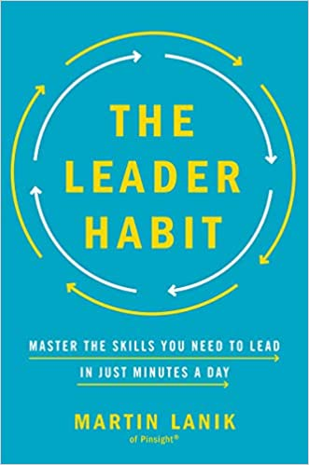
Book Club Meeting Discussion:
For our book discussion there were only two who completed the full book and the rest read some parts from the book. The book was more of an easy read but one that you can pick through and find the important aspects and apply the exercises when needed. We found the book can be useful information and one that you can mark up and turn back to for years. The books provide readers with the basis framework to help modify your behaviors, and help you build the leadership skills that can be used for daily exercises to help master leadership habits and skills. We found this book to be more a guide and reference to improve one’s leadership skills.
But overall, the readers found the book helpful and easy and engaging to read. This would be a book that would be helpful to have hard copy to make notes and reference back to the exercises.
Personal Comments:
As for my thoughts, I mainly used the audio version. It was nice to hear the book read aloud. I found it hard to follow without having a hard copy to refer to and physically see the exercises. I would like to potentially order the hard copy version and go through the audio read to understand the context better. I was not sure if the information provided was necessary anything new that I did not already know, but it was more broken down to a new way of viewing the information and start by creating habits.

